RGB Color Model

📘 Definition
# Source: AI Source: Provided by: [Data Path: Persons Table -> ID Column: 1, Name_En Column: Motasem Essam] -> From: [ChatGPT] on [5/2/2026]
The RGB color model is a system used in computers, phones, TVs, and other screens to create colors by mixing three primary colors of light:
- R = Red
- G = Green
- B = Blue
All colors you see on a screen are made by combining different amounts of these three lights.

🎨 How RGB works
# Source: AI Source: Provided by: [Data Path: Persons Table -> ID Column: 1, Name_En Column: Motasem Essam] -> From: [ChatGPT] on [5/2/2026]
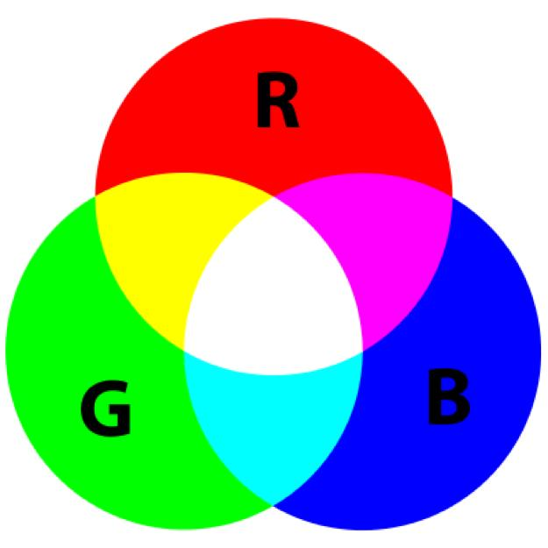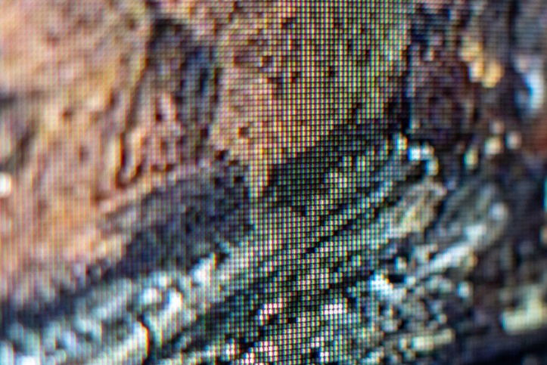
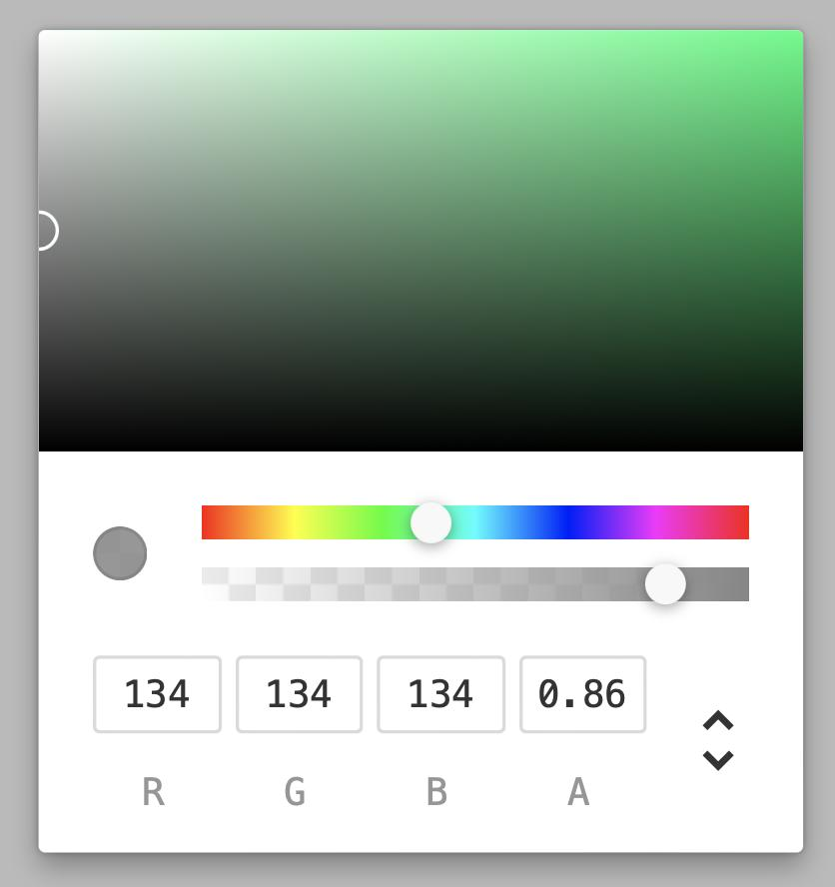
- If you mix all colors at full strength → you get white
- If you turn all off → you get black
- Different combinations create millions of colors
This is called an additive color system (because light is added together).

🧠 Examples of RGB values
RGB colors are written like this:
RGB(R, G, B) where each value is from 0 to 255
Here are simple examples:
- Black → RGB(0, 0, 0)
- White → RGB(255, 255, 255)
- Red → RGB(255, 0, 0)
- Green → RGB(0, 255, 0)
- Blue → RGB(0, 0, 255)

🎯 Mixed color examples
# Source: AI Source: Provided by: [Data Path: Persons Table -> ID Column: 1, Name_En Column: Motasem Essam] -> From: [ChatGPT] on [5/2/2026]
- Yellow → RGB(255, 255, 0) (Red + Green)
- Cyan → RGB(0, 255, 255) (Green + Blue)
- Magenta → RGB(255, 0, 255) (Red + Blue)
- Orange → RGB(255, 165, 0)

🖥️ Where RGB is used
# Source: AI Source: Provided by: [Data Path: Persons Table -> ID Column: 1, Name_En Column: Motasem Essam] -> From: [ChatGPT] on [5/2/2026]
- Computer monitors
- Smartphones
- TVs
- Digital cameras
- Games and animations

🚀 In short:
# Source: AI Source: Provided by: [Data Path: Persons Table -> ID Column: 1, Name_En Column: Motasem Essam] -> From: [ChatGPT] on [5/2/2026]
RGB color model = a way to create colors using Red, Green, and Blue light in different amounts.

